Thursday, 31st January 2019
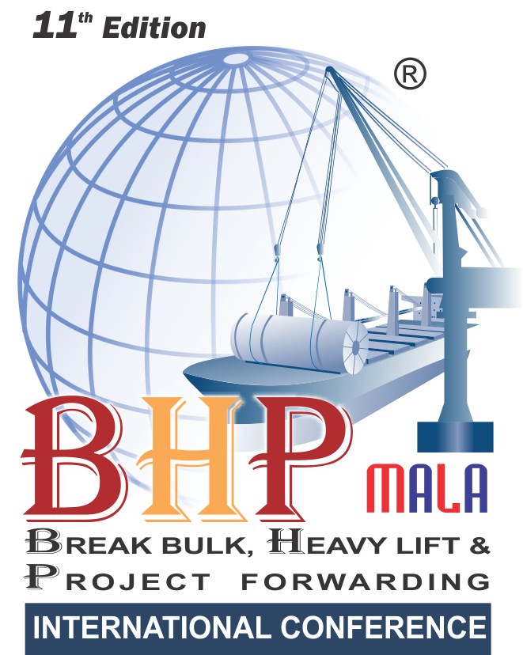
ENTRY FORM FOR NOMINATIONS
We are inviting companies to submit entries describing how they have demonstrated innovations and excellence or improved their services
or product offering within the regions.
Entries will be evaluated against the set of criteria by panels of judges who will select and shortlist the winner for each category.
Qualifying Period : April 2017 to March 2018

Region
: All India
Categories (Please tick your nominated category):
P Use this symbol for selection of categories * Self Nomination & Suggestions/Recommendations are must
NOMINEE :
Name of the Person:
Name of the Company: Address: Telephone Number: E-mail Address:
NOMINATED BY:
Name of the Person:
Name of the Company: Address: Telephone Number: E-mail Address: Describe the achievements in not more than 500 words:
•
Supporting Documents: Only a limited amount of supporting documents may be submitted. (Eg. Relevant Certificates and Documents
pertaining to specified criteria norms only.)
Electronically completed entry should be mailed to : nominations@exim-india.com
Note: No entries will be accepted in hard copy.
•
•

NOMINATION DEADLINE: SATURDAY, DECEMBER 15, 2018

To submit nominations in more than one categor y, use separate forms
PORT OF THE YEAR
LOGISTICS SOLUTIONS PROVIDER OF THE YEAR -
PACKAGING
IT AND SOFTWARE COMPANY OF THE YEAR (LOGISTICS INDUSTRY)
CORPORATE SOCIAL RESPONSIBILITY AWARD*
NEWSMAKER OF THE YEAR *
SHIPPING LINE OF THE YEAR - RO-RO OPERATOR
SHIPPING AGENT OF THE YEAR - BREAK BULK
WOMAN PROFESSIONAL OF THE YEAR *
DYNAMIC LOGISTICS PROFESSIONAL OF THE YEAR *
HEAVY LIFT OPERATOR OF THE YEAR
PROJECT MOVER OF THE YEAR

SHIPPING LINE OF THE YEAR – BREAK BULK

SHIPPING AGENT OF THE YEAR - PROJECTS
LOGISTICS COMPANY OF THE YEAR *
YOUNG LOGISTICS PROFESSIONAL OF THE YEAR *
FREIGHT FORWARDER OF THE YEAR - PROJECT CARGO
LIFETIME ACHIEVEMENT AWARD *
DEAL OF THE YEAR*
SHIPPING LINE OF THE YEAR - HEAVY LIFT OPERATOR
NVOCC OF THE YEAR ( SPECIAL EQUIPMENT)
STANDALONE AWARDS
**The Jury/ Organisers reserve the right to make changes to the list of categories if required; due to lack of sufficient nominations/ dearth of information, etc. The decision of the Jury / Organisers will be final & binding.

